Tables and Figures

Table 1: Results from negative binomial generalized linear mixed models (lme4, glmer.nb) testing for differences in frequency of pollinator floral visits and foraging bouts in response to microsite (shrub and open) and blooming stage (pre-blooming and full bloom). Conspecific floral density was included as a predictor and the log-transformed length of video was used as an offset as a measure of exposure. The repID (shrub ID + microsite) was used a random effect in both models to account for the repeated measures study design. Significance was denoted at α = 0.05 and shown in bold. Non-significant interactions were excluded from all models.

|  |  |  |  |  |  |  |
| --- | --- | --- | --- | --- | --- | --- |
|  | Total flower visits | | | Foraging bouts | | |
|  | **Coeff** | **χ2** | **p** | **Coeff** | **χ2** | **p** |
| Microsite (shrub) | -0.3493 | 4.4979 | **0.03396** | -0.3258 | 5.1183 | **0.0237** |
| Blooming (bloom) | -1.2473 | 61.52 | **<0.0001** | -1.2513 | 76.883 | **<0.0001** |
| Flowers.pot | 0.0694 | 6.9013 | **0.0086** | 0.0474 | 4.1109 | **0.0426** |
| Microsite * Blooming | NA | NA | NA | NA | NA | NA |

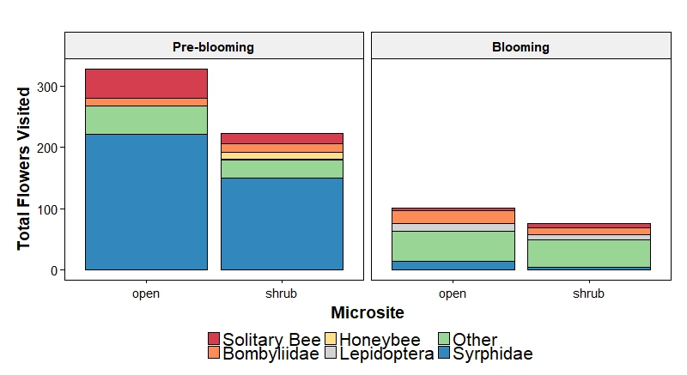

Figure 1: The contribution of each recognizable taxonomic group (RTU) to the total number of flowers visited (weighted by video length) for each treatment.

Table 2: Results from negative binomial GLMM (glmmTMB) testing for differences in frequency of pollinator floral visits and foraging bouts in response to microsite (shrub and open), blooming stage (pre-blooming and full bloom) and heterospecific annual floral density and shrub blooming density. Conspecific floral density was included as a predictor and the log-transformed length of video was used as an offset as a measure of exposure. The repID (shrub ID + microsite) was used a random effect in both models to account for the repeated measures study design. Significance was denoted at α = 0.05 and shown in bold.

|  |  |  |  |  |  |  |  |  |
| --- | --- | --- | --- | --- | --- | --- | --- | --- |
|  | Total flower visits | | | | Plant visits | | | |
|  | **Coeff** | **SE** | **z** | **p** | **Coeff** | **SE** | **z** | **p** |
| Microsite (shrub) | -0.36598 | 0.16944 -2.160 | -2.160 | 0.03077 | -0.33019 | 0.14706 | -2.245 | 0.02475 |
| Blooming (bloom) | -1.23964 | 0.16353 | -7.581 | 3.44e-14 | -1.24571 | 0.14513 | -8.584 | < 2e-16 |
| Flowers.pot | 0.08084 | 0.02711 | 2.981 | 0.00287 | 0.05943 | 0.02374 | 2.503 | 0.01230 |
| Heterospecific annual bloom density | 0.04013 | 0.02342 | 1.713 | 0.08664 | 0.04086 | 0.01984 | 2.059 | 0.03950 |

|  |  |  |  |  |  |  |  |  |
| --- | --- | --- | --- | --- | --- | --- | --- | --- |
|  | Total flower visits | | | | Plant visits | | | |
|  | **Coeff** | **SE** | **z** | **p** | **Coeff** | **SE** | **z** | **p** |
| Microsite (shrub) | -0.32888 | 0.16998 | -1.935 | 0.05301 | -0.31539 | 0.14829 | -2.127 | 0.033435 |
| Blooming (bloom) | -1.16615 | 0.18601 | -6.269 | 3.63e-10 | -1.20875 | 0.16707 | -7.235 | 4.66e-13 |
| Flowers.pot | 0.07598 | 0.02703 | 2.811 | 0.00494 | 0.05296 | 0.02376 | 2.229 | 0.025799 |
| Heterospecific blooming shrub density | -0.04940 | 0.04093 | -1.207 | 0.22744 | 0.03124 | 0.03744 | -0.835 | 0.403997 |

Table 3: Results from quasi-poisson generalized linear mixed models (MASS, glmmPQL) testing for differences in frequency of RTU specific pollinator floral visits and foraging bouts in response to microsite (shrub and open) and blooming stage (pre-blooming and full bloom). Conspecific floral density was included as a predictor and the log-transformed length of video was used as an offset as a measure of exposure. The repID (shrub ID + microsite) was used a random effect in both models to account for the repeated measures study design. Significance was denoted at α = 0.05 and shown in bold.

|  |  |  |  |  |  |  |
| --- | --- | --- | --- | --- | --- | --- |
|  | Total flower visits | | | Plant visits | | |
|  | **Coeff** | **χ2** | **p** | **Coeff** | **χ2** | **p** |
| Microsite (shrub) | -0.337480 | 4.1903 | 0.040655 | -0.311383 | 4.6322 | **0.03137** |
| Blooming (bloom) | -1.729417 | 15.4730 | < 0.0001 | -1.683054 | 12.2157 | **0.0004739** |
| RTU | NA | 197.0575 | <0.0001 | NA | 217.5031 | **<0.00001** |
| Flowers.pot | 0.064325 | 7.8743 | 0.005014 | 0.042763 | 4.0741 | **0.4354** |
| RTU*blooming | NA | 70.0222 | <0.0001 | NA | 70.35 | <0.0001 |

Table 4: Results from post-hoc test (lsmeans, Tukey’s) for the quasipoisson GLMM for both frequency of floral visits and foraging bouts.

Flower visits post-hoc test.

|  |
| --- |
| Solitary bee |
| contrast estimate SE df t.ratio p.value |
| Flower: pre - bloom 1.72941690 4.418547e-01 1276 3.914 0.0001 |
| Plant : pre - bloom 1.6830539 4.839527e-01 1276 3.478 0.0005 |
| Bombyliidae |
| contrast estimate SE df t.ratio p.value |
| Flower: pre - bloom 0.04602546 3.886082e-01 1276 0.118 0.9057 |
| Plant: pre - bloom 0.3956475 3.556753e-01 1276 1.112 0.2662 |
| Honeybee |
| contrast estimate SE df t.ratio p.value |
| Flower: pre - bloom 24.99689016 7.783803e+04 1276 0.000 0.9997 |
| Plant: pre - bloom 24.3349238 6.530236e+04 1276 0.000 0.9997 |
| Lepidoptera |
| contrast estimate SE df t.ratio p.value |
| Flower: pre - bloom -2.40174164 1.289996e+00 1276 -1.862 0.0629 |
| pre - bloom -2.0770886 1.062522e+00 1276 -1.955 0.0508 |
| Other |
| contrast estimate SE df t.ratio p.value |
| Flower: pre - bloom -0.01969237 2.403112e-01 1276 -0.082 0.9347 |
| pre - bloom 0.1340573 2.064640e-01 1276 0.649 0.5163 |
| Syrphid |
| contrast estimate SE df t.ratio p.value |
| Flower: pre - bloom 3.05632296 3.468089e-01 1276 8.813 <.0001 |
| Plant: pre - bloom 3.1228613 3.404428e-01 1276 9.173 <.0001 |

Table 5: Results from negative binomial generalized linear mixed models (lme4, glmer.nb) testing for differences in arthropod abundance in response to microsite (shrub and open) and blooming stage (pre-blooming and full bloom). Melyridae beetles comprised 1217/3384 individuals, models were fit with them excluded, included and individually. The repID (shrub ID + microsite) was used a random effect in both models to account for the repeated measures study design. Significance was denoted at α = 0.05 and shown in bold. Non-significant interactions were excluded from all models.

|  |  |  |  |  |  |  |  |  |  |
| --- | --- | --- | --- | --- | --- | --- | --- | --- | --- |
|  | Insect abundance (Melyridae: Dastyine excluded) | | | Insect abundance (Melyridae: Dastyine included) | | | Melyridae:Dastynine abundance only | | |
|  | **Coef** | **χ**2 value | p – value | **Coef** | **χ**2 value | p – value | **Coef** | **χ**2 value | p – value |
| Microsite  (shrub) | 0.40610 | 15.4926 | **<0.0001** | -0.09872 | 1.808 | 0.1787 | -1.1920 | 38.0394 | **0<0.0001** |
| Blooming  (in bloom) | -0.39624 | 13.5868 | 0.000228 | -0.39280 | 33.553 | **<0.00001** | -0.2989 | 3.3485 | 0.067267 |
| Microsite * Blooming | -0.27673 | 3.4553 | 0.063049 | NA | NA | NA | 0.6521 | 7.1290 | 0.007585 |

Abundance contrasts

$contrasts

contrast estimate SE df z.ratio p.value

pre,open - post,open 0.3962370 0.1074971 NA 3.686 0.0013

pre,open - pre,shrub -0.4060998 0.1031742 NA -3.936 0.0005

pre,open - post,shrub 0.2668669 0.1060437 NA 2.517 0.0574

post,open - pre,shrub -0.8023367 0.1044866 NA -7.679 <.0001

post,open - post,shrub -0.1293701 0.1073211 NA -1.205 0.6234

pre,shrub - post,shrub 0.6729667 0.1029908 NA 6.534 <.0001

Melyridae only constrasts

pre,open - post,open 0.2989089 0.1633482 NA 1.830 0.2592

pre,open - pre,shrub 1.1920062 0.1932688 NA 6.168 <.0001

pre,open - post,shrub 0.8388073 0.1826136 NA 4.593 <.0001

post,open - pre,shrub 0.8930973 0.1906721 NA 4.684 <.0001

post,open - post,shrub 0.5398984 0.1799142 NA 3.001 0.0143

pre,shrub - post,shrub -0.3531989 0.1815186 NA -1.946 0.2090

Table 6: Results from poisson generalized linear mixed models (lme4, glmer.nb) testing for differences in bee abundance and arthropod species richness in response to microsite (shrub and open) and blooming stage (pre-blooming and full bloom). The repID (shrub ID + microsite) was used a random effect in both models to account for the repeated measures study design. Significance was denoted at α = 0.05 and shown in bold. Non-significant interactions were excluded from all models.

|  |  |  |  |  |  |  |
| --- | --- | --- | --- | --- | --- | --- |
|  |  | Species Richness | | Bee abundance | | |
|  | **Coef** | **χ**2 value | p – value | **Coef** | **χ**2 value | p – value |
| Microsite | 0.14541 | 6.6289 | 0.01 | 0.05766 | 0.0792 | 0.778323 |
| Blooming | -0.25442 | 25.6295 | **<0.0001** | -0.0787 | 0.2104 | 0.646419 |
| Microsite * Blooming | NA | NA | NA | NA | NA | NA |

Table 7: Results from negative binomial generalized linear mixed models (lme4, glmer.nb) testing for differences in annual percent cover, annual species richness and annual blooming density in response to microsite (shrub and open) and blooming stage (pre-blooming and full bloom). The repID (shrub ID + microsite) was used a random effect in both models to account for the repeated measures study design. Significance was denoted at α = 0.05 and shown in bold. Non-significant interactions were excluded from all models.

|  |  |  |  |  |  |  |
| --- | --- | --- | --- | --- | --- | --- |
|  | Percent cover | | Annual Richness | | Annual bloom density | |
|  | **χ**2 value | |  | |  | |
|  |  | p – value | **χ**2 value | p – value | **χ**2 value | p – value |
| Microsite | **165.399** | **<0.0001** | 0.7071 | 0.40 | 0.6009 | 0.438 |
| Blooming | **34.180** | **<0.0001** | 2.7010 | 0.10 | **13.3646** | **0.0003** |
| Microsite * blooming | **22.806** | **<0.0001** | NA | NA | NA | NA |

Table 8: Visit duration (Gamma).

|  |  |  |  |  |  |  |  |  |
| --- | --- | --- | --- | --- | --- | --- | --- | --- |
|  |  | Visit duration | |  | **Proportion of flowers visited** | |  | |
|  |  |  | |  |  | |  | |
| Presence | **Coef** | **χ**2 value | p – value | **Coef** | **χ**2 value | p – value | **χ**2 value | p – value |
| Microsite | -0.047260 | 0.0464 | 0.8295 | -0.03538 | 1.0051 | 0.46515 |  |  |
| Blooming | -0.777931 | 23.1788 | 1.476e-06 | 0.08050 | 0.5335 | 0.31609 |  |  |
| Microsite * Blooming | NA | **NA** | **NA** | -0.20443 | 7.0691 | 0.00784 |  |  |

Table 9: Linear mixed models for subsets of RTU.

|  |  |  |  |  |  |  |  |  |
| --- | --- | --- | --- | --- | --- | --- | --- | --- |
|  | Bee |  |  |  |  | Other |  |  |
|  | Coef | X | P | t | Coef | X | p | t |
| Blooming | -0.9341 | 1.9017 | 0.208 | -1.379 | -1.0703 | 12.274 | 0.000605 | -3.503 |

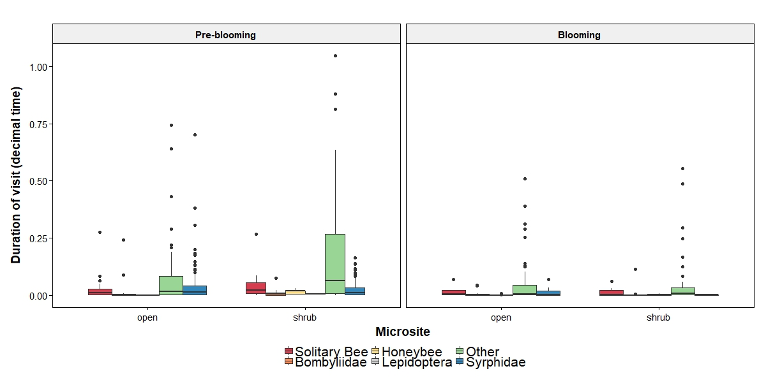

Figure 2: Visit duration by RTU

Figure 3: Proportion visited by RTU

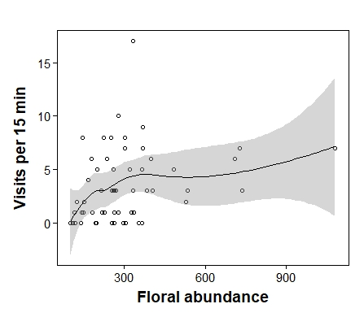

Figure 4: Visitation by floral number of larrea

Figure 5: All RII

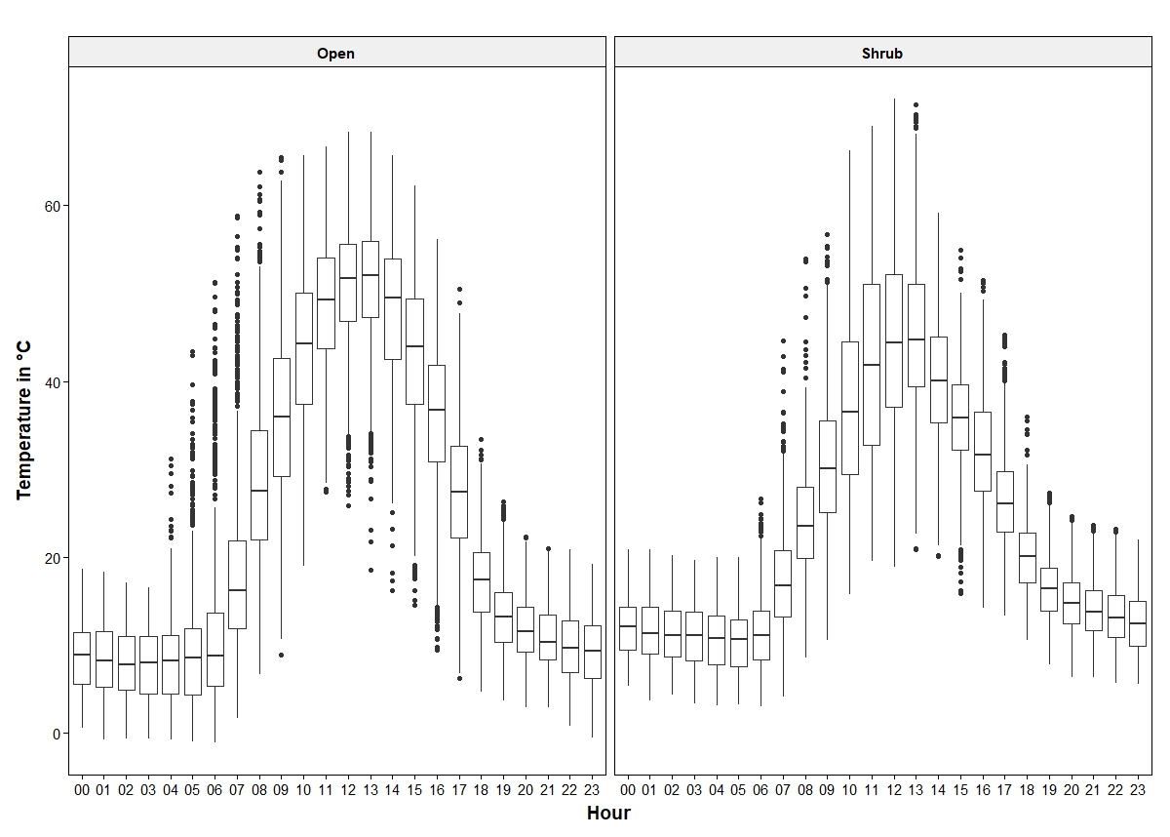

Figure 6: Mean hourly temperatures for each microsite (open and shrub). This is from March 16th to May 17th or so. Hobo Pendant Data Loggers.

Estimate Std. Error t value Pr(>|t|)

(Intercept) 0.7820540 0.2417340 3.235 0.00204 **

n.flowers 0.0013408 0.0005728 2.341 0.02283 *

Larrea visitation

LR Chisq Df Pr(>Chisq)

n.flowers 4.6383 1 0.03127 *

Table: Results from quasipoisson GLMM

|  |  |  |  |  |  |  |
| --- | --- | --- | --- | --- | --- | --- |
|  |  | **Conspecific** | | **Heterospecific** | | |
|  |  |  | |  |  | |
| Presence | **Coef** | **χ**2 value | p – value | **Coef** | **χ**2 value | p – value |
| Distance to Larrea | 0.000200 | 0.8803 | 0.3533 | 0.0013047 | 23.7883 | 1.075e-06 |
| Distance to M.glabrata | 0.001480 | 3.8146 | 0.0541 | -0.0013985 | 2.1656 | 0.1411 |
| M. glabrata floral number | 0.008945 | 2.0027 | 0.1620 | -0.0122049 | 2.3713 | 0.1236 |

Table infinity:

|  |  |  |  |  |  |  |  |  |  |  |
| --- | --- | --- | --- | --- | --- | --- | --- | --- | --- | --- |
|  | | Mean Daytime Temperature | | | Mean Nightime Temperature | | | Variation | | |
|  | **Coef** | | **χ**2 value | p – value | **Coef** | **χ**2 value | p – value | **Coef** | **χ**2 value | p – value |
| Shrub  Microsite | -0.064678 | | 85.51 | -9.247 | 0.059203 | 50.121 | 1.45e-12 | -0.27977 | 523.38 | <2e-16 *** |